SYNTAX

Syntax studies the organisation of words in sentences. It cares about the order of words, how words are put together in groups called constituents (is a word or a group of words that function as a single unit within a hierarchical structure) and the relationship between words in sentences.
Ex: The kids have all read the book (kids and all are separated but they have to be together)

Different order gives different meanings
- Grandma hugs the little girl
- The little girl hugs grandma

Different ways of putting words together give different meanings
- The wizard applauds the [smurf on the stool]
- The wizard applauds the [smurf] on the stool
(the meaning depends on how we group words together to form constituents🡪 the verb applauds could lead a single constituent smurf on the stool, or two different constituents smurf, on the stool)

Words in the utterances groups together to form Constituents and these constituents are organized hierarchically. How can we identify relationships between constituents?
- My friend cleaned the floor with a broom (in this case the constituents are: my friend, the floor, cleaned the floor; the rest is not a constituent 🡪 they are an intermediate units between the sentences and the individual words that compose it)

How can we determine if something is a constituent? There are some tests to determine if something is a constituent or not:

1.Constituents tests: Cleft / Clefting
Taken the previous example, My friend cleaned the floor with a broom, we can state that a constituent could be moved in a sentence:
- It is with the broom that my friend clean the floor (with the broom it is a constituent because can in the previous example it was in other part of the sentence) 🡪 we have a form a cleft sentence (complex sentence that could be expressed as a simpler sentence)
In contrast, if we try to move only the broom we can see that it could not be considered a constituent:
- It is the broom that my friend cleaned the floor with (this sentences does not make sense, so the broom is not a constituent)
It is X (the constituent) that rest of the sentence without X. Only sequences of words that form a constituent can follow the verb be in a cleft sentence. For instance, it is the floor that my friend cleaned with the broom (but if we change the floor with floor is not anymore acceptable).

There are a number of syntactic operations that we can do on groups of words that are constituents; knowing how to do such operations is knowing how to speak a language. We can use these operations to explixcity know if a group of words is a constituent.

2.Constituent tests: Use in isolation
A friend of mine cleaned the floor with a broom last night
1. Who cleaned the floor? 🡪 A friend of mine
2. What is it that a friend of mine cleaned? 🡪 The floor
3. What did a friend of mine clean the floor with? 🡪 with a broom
4. When did a friend of mine clean the floor) 🡪 Last night
English is one the few languages in which you can use this test to find constituents.

3.Constituent tests: Proform substitution
For example, a nominal group can be replaced by a pronoun (only if the pronoun exists in the language). If substitution is possible, the replaced word group forms a constituent:
- A friend of mine cleaned the floor with a broom.
- He cleaned it with a broom.

- A friend of mine went to Rome
- A friend of mine went there

- Does she drive to the mountains? She does (verbal phrase)
- My kids baked cookies for Halloween. Did they? (verbal phrase)
- Frida gave her dog to Franky and Mary too (too is referred to the constituent)

A constituent could be form by one or more words:
- I saw Mary 🡪 I saw her
- I saw the cat from the next door 🡪 I saw it

- I saw of mine cleaned the floor yesterday (only a sequence of owrds can be subtitutte by a pronoun but only if the pronoun exist in that specific language).

4.Constituent tests: Coordination
Only groups of words that form constituents of the same type can be coordinated:
- A friend of mine cleaned [[the floor] and [the terrace]] with the mob 🡪 SAME TYPE
- A friend of mine cleaned the floor [[with the broom] and [with the mob]] 🡪 SAME TYPE
- A friend of mine cleaned [the floor] and [with the broom] 🡪 constituents are NOT of the same type.

In our mental grammar we could distinguish what is a constituent and what is not. We also know how to divide constituents into different types (nominal, prepositional, adjective…) and we combine them according to certain schemes which fix their mutual compatibility.
The tests to find if something is a constituent or not are not absolute. Sometimes one test may not function (for instance, there is not a pronoun in a determinate language).
Constituent structure reflects the ways in which heads and dependents are combined at a syntactic level to form a scaffolding for the construction of semantics relationships (who does what to whom 🡪 our goal).

Summary:
- Constituents: between words and sentences
- Constituent tests are: it is X that sentence, Isolation, Proform, Coordination
- Ambiguity

Exercise: show which are the constituents is these sentences
- We must talk to her 🡪 to her is a constituent (it is to her that we must talk)
- She is trying to solve the problem 🡪 the problem is a constituent
- They are expecting you to contact them 🡪
- John bought an apple 🡪 apple is a constituent

Constituents and ambiguations
The ambiguations arises by the different ways in which you put words together in constituents:
Ex: The policeman chased the thief with the motor. Here there are two interpretations:
- Chased attached to 🡪 the thief (the thief AND with the motor are two sub-constituents)
- Chased attached to 🡪 the thief with the motor (the thief with the motor is a big constituent)
How can we prove that the thief with the motor and with the motor are two constituents? We can is it X test: move the constituents to prove what is the correct interpretation 🡪 the sentence is not any more ambiguous (the correct interpretation is either the first or second)
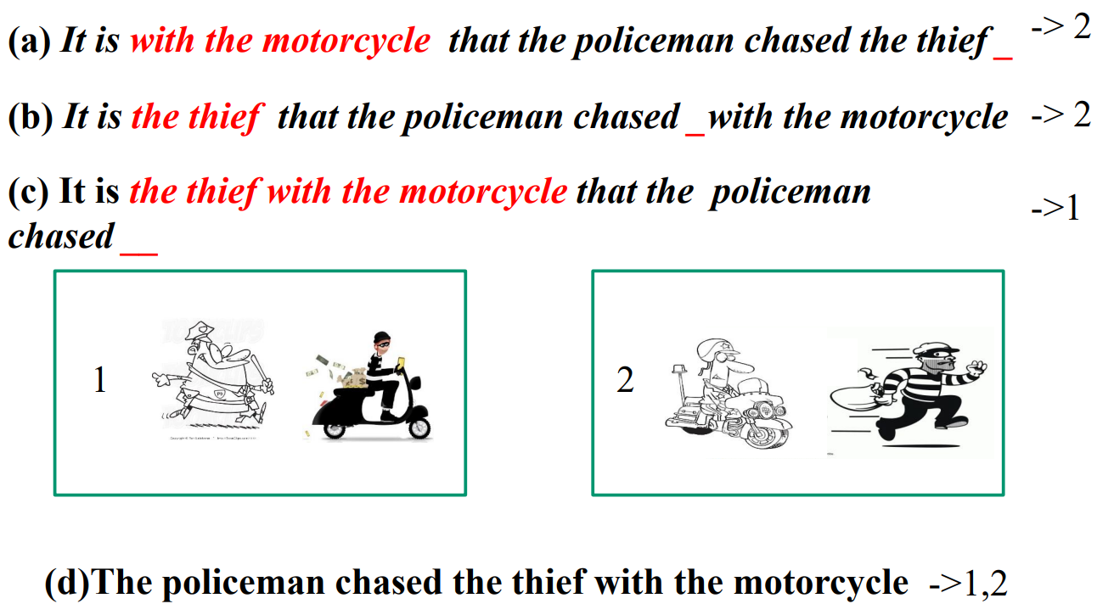
This example shows that sentences are not sequence in a row: words are put together make and modify interpretations.
We can prove this example also with other tests:
- Isolation: Who did the policeman chase with the motorcycle?
- Proform: The policeman chases him with the motorcycle
- Coordination: The policeman chase the thief and the girl with the motorcycle

Another example: Mary saw the spy with the binocular 🡪 It is ambiguous, it has two interpretations: (i) Mary used the binocular or (ii) The spy was the one with the binocular 🡪 the two interpretations corresponds to two different ways of organizing constituents. We use the TESTS that we have seen:
- It is with the binocular that Mary saw the spy 🡪 No longer ambiguous: Mary uses the binocular (1 interpretation)
- It is the spy with the binocular that Mary saw 🡪 No longer ambiguous: The spy uses the binocular (2 interpretation)

The origin of ambiguity is the possibility of having different way of building constituents. To disambiguate sentences means to choose a certain analysis to constituents w.r.t. another. Since speakers can grasp ambiguities, they implicitly make an analysis into constituents.

The concept of constituent is vague: we need an explicit notion 🡪 phrase.
- [In general: verbal phrase are technical concepts, instead constituents are not technical concepts but it is a concept we share because we are human]

Verbal phrase (VP)
They are a group of words gathered around the verb according to a precise structural scheme. But how words are gathered around the verb? How these words are organized w.r.t. the verb?
- The policeman wants to chase the thief with the motor and so does the lady 🡪 DOES WHAT? [chase the thief with the motor].
Wants: we have separated the lemma of the verb from the inflection (and we have separated the first verb from the second) ??.

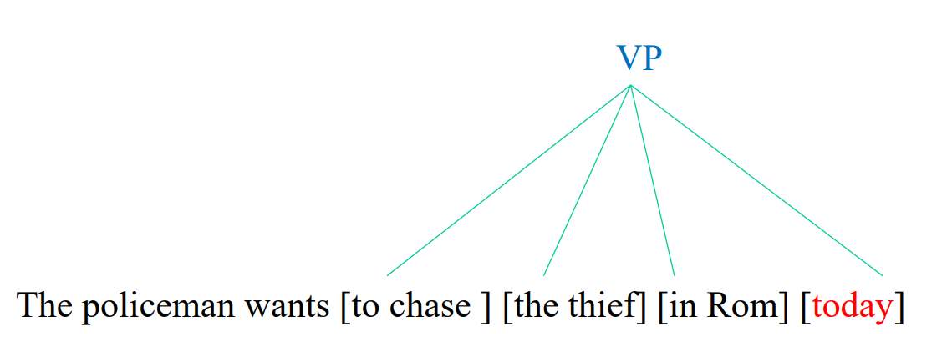
The verb here chase is the main protagonist and it called head. Then we have same dependents 🡪 the group of words that is around the V form a verbal phrase (VP)

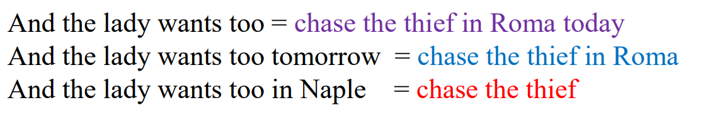
A first possibility to put them at the same level. BUT is NOT correct because it is ambiguous: I can’t elide words because they are at the same level

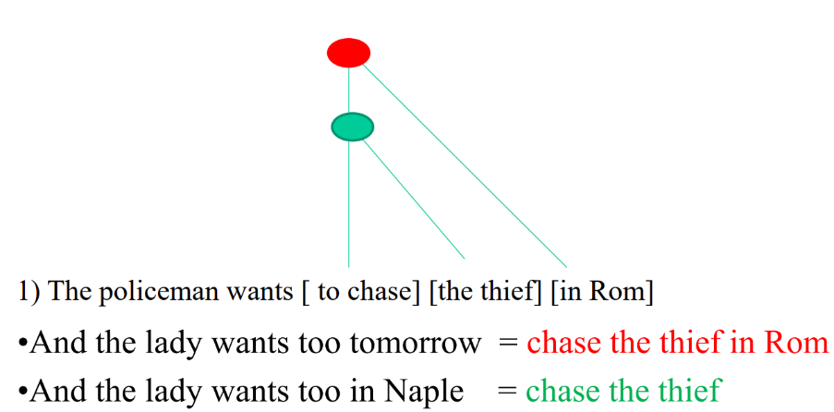
The appropriate representation of this sentence is a hierarchical relation: what is under a node can be elided to form a group of words that are homogenous

Take this sentence:
The policemen have all chased the thief in Rome, where does all stay? With the verb?
- The policemen have all chased the thief in Rome and the ladies have too (what have I elided? 🡪 all chased the thief in Rome) 🡪 this means that all goes with the lexical verb chased
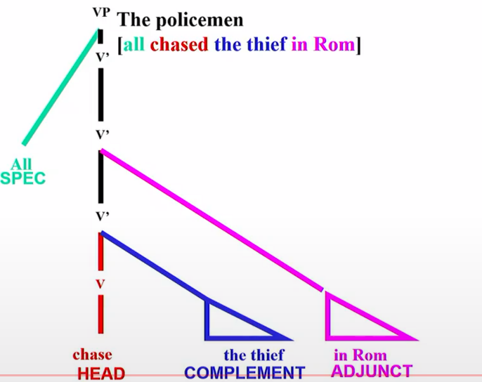
Here we have the representation of the VB (this type of phrase includes the event and the protagonist of the event) with the verb chase:
- The complement the thief is directed connected to head/verb chase. A complement is something that is necessary to complete the meaning of the verb.
- The adjunct in Rome is connected to the head chase with the complement the thief. An adjunct is something not necessary to complete the meaning, it adds only new things.
- The specifier all hosts the subject and it is at the highest level: if I elide this, then all the phrase changes

Head: the head of a constituent/phrase is that sub-constituent which determines the internal structure and external distribution of the constituent as a whole:
- John gave Sandy books
- John gave books to Sandy (with the verb gave we can accommodate objects)
- John saw Sandy
- John saw Sandy books (in this case, saw has not an internal structure to accommodate an object)
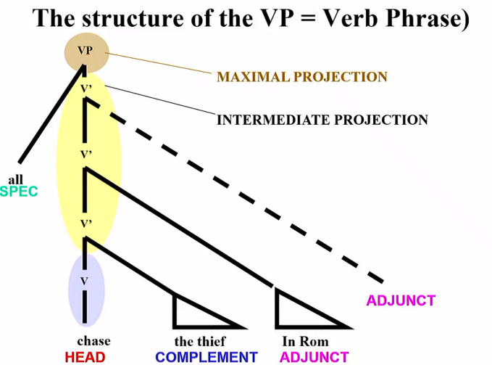

- Maximal projection: include everything that stays with the verb
- Intermediate projection: includes complement, adjuncts
- Head: it is the last part and corresponds to the verb (in verbal phrases)

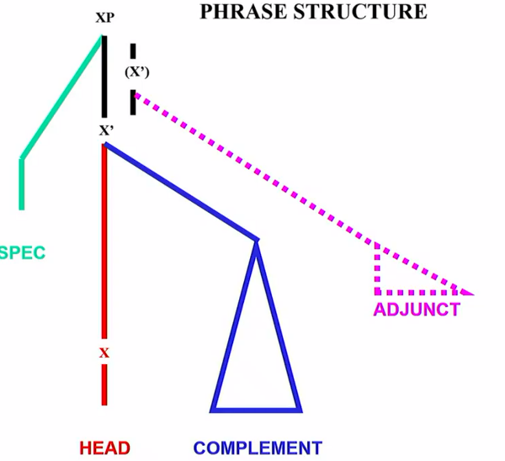
General phase structure
We can change the category to have other phrases:
- Head: it is always present because it defines the type of the phrase.
- Complement: they are obligatory in certain cases but for instance, in transitive verbs they are not necessary.
- Adjunct: it could add new meanings at the phrase.
- Specifier: it specifies the subjects of the phrase.

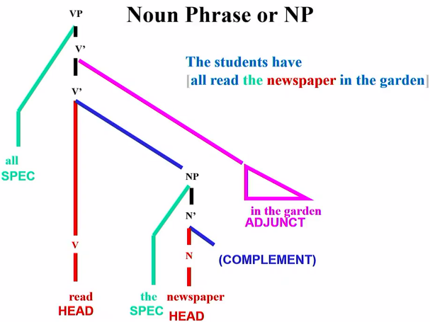
Noun phrase (NP)
The students have all read the newspaper in the garden. It has the same identical structure of the verbal phrase, but with the only difference is that the head is a noun (newspaper).
In this case, the noun phrase is inside the verbal phrase: here it is applied the concept of recursion

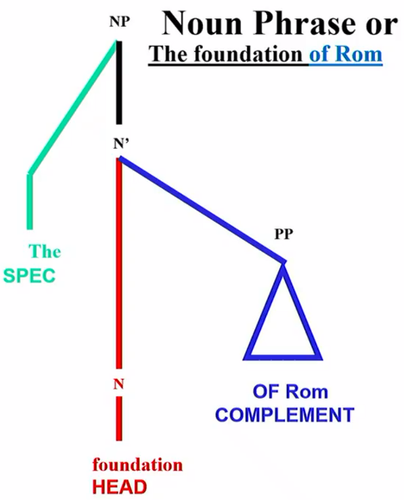
The sentence is: The foundation of Rome.
In this case foundation is a relational noun: it denotes an event that has an agent that founds and something that is founded.
So that means that of Rome in this case is a complement and NOT an adjunct (because the root of the verb requires of Rome as complement) 🡪 Nouns can also have complements.
PP means propositional phrase (because of Rome starts with OF that is a proposition)
We can also add an adjunct at higher level (for instance we can add next to the Tevere)

Complement or Adjunct?
Dependents (so complements and adjuncts) are of two types:
- Arguments: are dependents which are syntactically selected or licensed by the head and typically complete the meaning of a predicate
- Adjuncts: are dependents which do not need to be licensed and are not selected for by the head and which refine the meaning of a complete predication

Exercises: arguments or adjuncts?
- Maty invited Lucy yesterday 🡪 yesterday argument.
- Mary offered a book to Mary in Rome 🡪 a book argument, to Mary argument, in Rome adjunct.
- Lucy went to Rome in train 🡪 to Rome argument/adjunct, in train adjunct.
There are many problems and ambiguities in distinguishing between adjuncts and arguments.

Proper nouns: usually, these types of phrases don’t have complements and don’t have specifiers.

Propositional phrase: for instance, of Rome is a propositional phrase with head of and complement Rome.

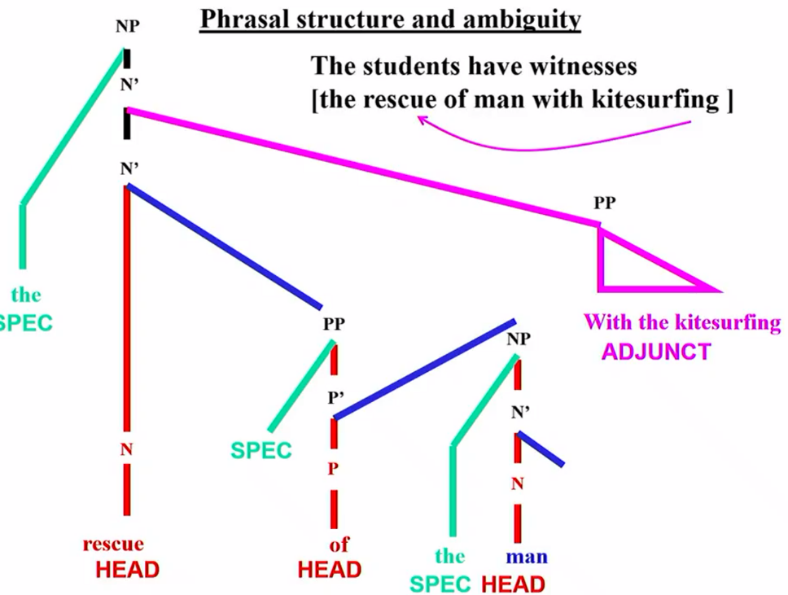
Complex Phrase:
[the rescue of man with kitesurfing] – with kitesurfing could be attached to different levels changing the meaning of the phrase (as we have done for the verbal phrase)

The structure of sentences: IP
- The policemen have all chased the thief in Rome 🡪 VP is all chased the thief in Rome, SPECIFIER The policemen, HEAD is have
- The students have all seen the show 🡪 VP is all seen, NP (inside the VP) is the show, NP is the students

Subordinate sentences
- John has said the truth
- John has said that Mary has called

Interrogative sentences
- John will read the newspaper after breakfast
- Will John read the newspaper after breakfast it has a different structure compared to an indirect question

- W questions like when will John read the newspaper? 🡪 when is a PP and stays in the superior-left part of the analysis.

X-bar theory
The notion that a head projects a domain in which it controls the dependents that appear and the overall character of the resulting constituent is at the core of many theoretical approaches to syntax including X-Bar Theory

Exercise: Find a sentence for this tree
- The teacher has taken the book from the library
- This boy has found a stone in the mountain

- The cat is eating

- The lady has said that she leaves tomorrow

The number of semantic arguments provided for by a head is a fundamental lexical property
Form – meaning is not 1-1:
- John ate
- John ate vegetables

- She loves to ride
- He rides his bike to school (go)
- I ride my son on my shoulders (carry)

- Convey 🡪 carry or transmit (same meaning)

In many languages, arguments can be left unexpressed
- John promised Bill to come
- John promised to come
- John promised that the next government would make a clean break
Unexpressed could be important for anaphora resolution:
- John washes himself
- John promised Bill to wash himself
- John promised Bill that he will wash himself
Boundaries between optionality (can or cannot have an argument) and homophony (two verbs sound the same but with different meaning)🡪 (1 form and 2 meaning)
- John ate
- John ate vegetables

Words fro fifferent parts of speech can serve as heads selecting arguments:
- Sandy’s arrival was earlier than expected
- ……….

- Kim is proud of that painting (-of that painting is an argument of the adjective proud)
- Sandy is unhappy about the weather (-about whether is an argument of the adjective unhappy)

Arguments vs Adjuncts – how to distinguish them
Adjuncts are not required by heads and generally can iterate:
- Sany ran in Berlin / on Saturday / at three o’clock / in the afternoon 🡪 3 temporal adjuncts

Arguments cannot iterate:
- Kim gave Sandy a book
- Kim gave Sandy [a book and a record] 🡪 but it is a single argument
- John offered book to Sandy to Mary

Another possibility to distringuish them: obligatoriness
- Kim put the pen on the table (-on the table is an argument)

Also entailment can be used as a test to distinguish them:
- Pat slept until noon 🡪 Pat did something
- Pat relied on Chris NOT🡪 Pat did something on

Adjuncts can be single words, phrases, or clauses
- Kim went sailing yesterday
- Sandy read a book on the bus
- Sandy kept reading the book while the bus is arriving

Verbal arguments
- V-intransitive: sleep 🡪 one argument
- V-transitive:

Intransitive verbs
Do not have a complement (in general but sleep a deep sleep 🡪 there are expections)

Transitive verbs
The complement could be

